Publish Data to the IBM Cloud

|  |  |
| --- | --- |
| Team ID | PNT2022TMID41040 |
| Project Name | Smart Waste Management System For Metropolitan Cities |

PYTHON SCRIPT

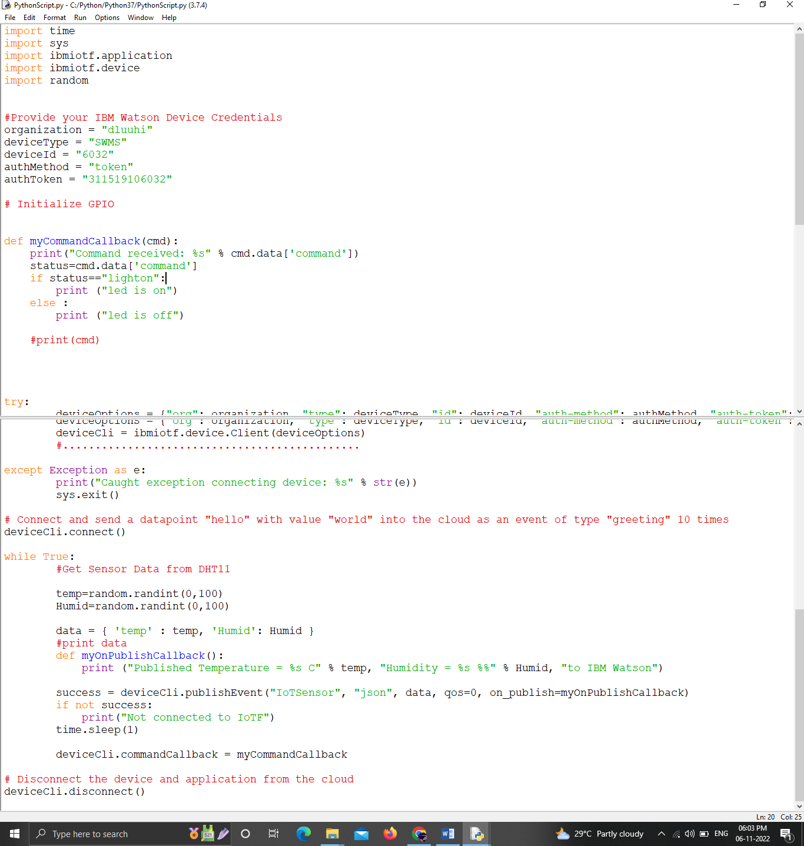

OUTPUT:

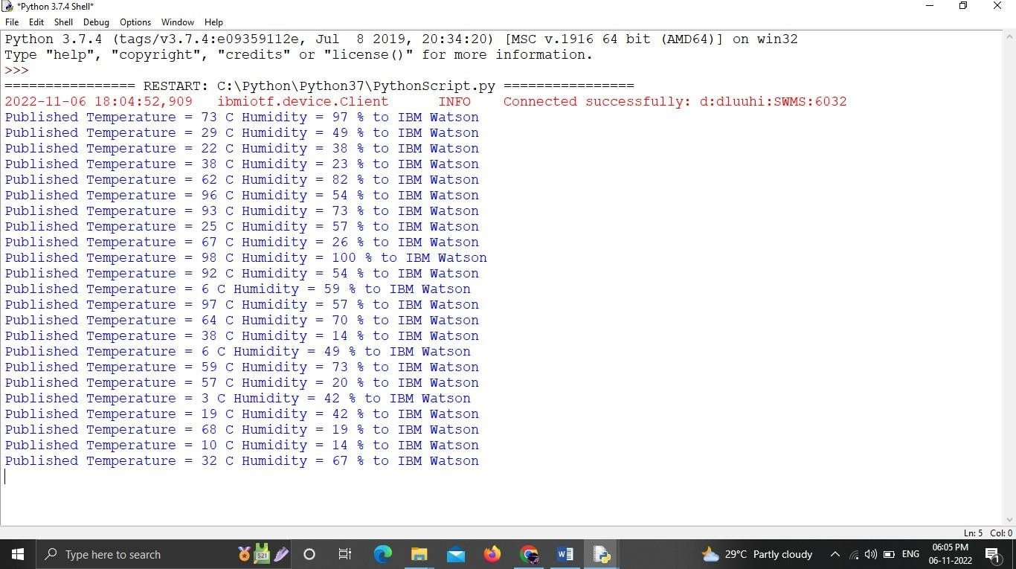

DATA IN IBM CLOUD PLATFORM:

